WARRANT OFFICER ASSOCIATION
CRATER CHAPTER # 0603
FORT LEE, VIRGINIA 23801

MEMORANDUM FOR RECORD DRAFT 4 December 2019

1. The Chapter President, CW4 Dan Howison, called the meeting to order at 1733.

2. Quorum - 10 (34 proxies) present to conduct the meeting, 2 visitors; Pledge of Allegiance was recited.

3. We welcomed the following visitors:
- CW5 James Fiorilli, NG, assigned to ALU to the Ordnance Dean’s Team, will transfer membership to Crater Chapter
- WOCC/SFC Cortney Johnson, , Warrant Officer 923A February 20 Candidate

4. Minutes from the 6 November 2019 meeting were reviewed by all. CW4 Wayne Sexton made a motion to accept the minutes subject to edit, and CW4R Janice Chayt seconded. Motion passed.

5. The Treasurer’s reports for November 2019 were read by all. CW4 Wayne Sexton made a motion to accept the reports subject to audit, and CW5 Sonya Graves-Rivers seconded. The treasurer’s reports for November 2019 passed.

6. Committee Reports:

a. Vice President Report CW4 Francis Pattin - Includes Membership statistics with reports from the Vice-President for Army Reserve/National Guard Affairs – CW5 James Williams- Vice-President for Retired Affairs – VACANT- and Vice-President for Junior Warrant Officer affairs VACANT- (VP-JWO) WO1 Tyrone Lander- see report.
b. Memorabilia – CW3 Karen Algernon-Wallace. See report. See report. Gave by CW4 Amy Scott
c. Volunteer Hour monitor- CW5R Vickie Vachon – see report.
d. Boy Scouts of America - CW4R Charlie Mills see report
e. JROTC High School Support – CW5 Nicole Woodyard
f. McGuire VA Support – CW5R Karen Ortiz
g. Rebuilding TriCities – CW5 Thomas Waltman -see report
h. Public Relations – CW5 Travis Elliott
.
7. Old Business.

a. Email exchanges from BOD members provided names on Fall Potluck. It was a successful event, and many have asked for this to be a repeat effort, with AAR lessons learned. Names of those who attended have been provided to volunteer hour coordinator CW5R Vickie Vachon, closing this effort.
b. CW5 Travis Elliott leads the committee for a Warrant Officer Ball. April 25, 2020 was the choice date for the event, but that date is not available. A site survey of the Marriott was conducted (date) with CW4 Pattin and CW5 Elliott, and options are now to use alternative dates 18 April, or 2 May or 9 May. Another hotel, Richmond Four Points, Marriott is also being reviewed for availability. The committee will continue to coordinate the event.
c. Rebuilding TriCities: CW5 Thomas Waltman now chairs that committee. Rebuilding TriCities is listed on calendar, and in Standing Orders as a supported action. CW5 Waltman attended the CW5 evening event versus the Chapter Meeting, thus this issue is tabled until next month as old business. Support application files are attached in the minutes for review and consideration.
d. CW5R Wayne Burton still has one meal vouchers for 2, for Members’ present raffle and one Crispy Cream donut voucher, donated by CW5 Sonia Graves-Rivera The proceeds from Refrigerator sales will purchase another. The plan is to draw for Crispy Cream in January and the Romas Meal Voucher for two in February supporting a Valentines meal.
e. Holiday Helper date is 11 December 2019 from 1100-1300 hours. Helpers are CW4R Charlie Mills, WOCC SFC Courtney Johnson, CW5R Vickie Vachon, CW4 Dan Howison, CW5 Travis Elliott and CW4R Janice Chayt. We are allotted two hours, members will be wrapping gifts and walking with parents as they pick out gifts for their child/children. The names will be listed in the report. Volunteers to transport items, a pre-mission to enable the Holiday Helper event are reflected on chart in minutes.
f. Wreaths Across America event is December 14th at City Point National Cemetery (Avis St, Hopewell, VA 23860) starting at 11am.
g. McGuire VA Bingo Christmas event is scheduled for Saturday 28 Dec 2019 from 1230-1530 at 1201 Broad Rock Boulevard, Richmond, VA 23249. Volunteers will help the veterans with the Bingo cards, pass out snacks, canteen bucks, and clean up the multi-purpose center upon completion of the event. Event will occur on the 1st Floor McGuire Multi-purpose Room. Funds: $300 in September, was designated for snacks /canteen bucks. POC: CW5R Karen Ortiz.
h. CW4 Francis Pattin and CW4R Charlie Mills presented ACS the Crater Chapter donation check for Thanksgiving and Christmas. Action closed. See photo in the minutes.
i. CW4 Dan Howison will take the high school JROTC program for the TriCities area. CW5 Nicole Woodyard will continue with the charter school, __________. Dan will disperse the questions for competition essays derived from the pool of old scholarship program questions.
j. Scholarship questions. CW5 Vickie Vachon will forward to the BOD for down-select of the 2020 Crater Scholarship Program questions during December and present them at the January 2020 meeting. The questions and Scholarship program write up will be placed in the Fort Lee Traveler in the month of January.

8. New business:

- CW4 Francis Pattin’s retirement ceremony was 11am 20 December, 2019 at the Quartermaster Museum. Colonel Lanier was the guest speaker. Mr. Pattin closed out a 25 year career with a standing room only ceremony.
- CW5 Nicole Woodard will have her retirement ceremony 24 Jan 2020 at TBD location at time TBD.
- CW4R Janice Chayt wants to deliver cookies on Fort Lee during the Christmas Holidays and is interested in getting information to who her cookies can be delivered to and when.
d. Crater Chapter Private Organization paperwork will be prepared for signature and staffing beginning now until April 2020. CW4 Dan Howison will provide paperwork for CW4 Francis Patting, the incoming President.
e. Bylaws. CW5R Wayne Burton, CW5R Vickie Vachon and CW4R Charlie Mills will edit the current Chapter Bylaws to reflect the March 2020 award of Silver Chapter status. The project begins in January and will be complete NLT March.
f. Crater 2020 raffle. CW4R Charlie Mills made a motion to conduct a raffle beginning next year to provide chapter income, with goal to fund the Crater Ball. The Plan is to purchase gift cards for $100 in Jan 20 and $100 in Feb 20 and two Crater Ball tickets in March 20. There was no vote. Because there was not a volunteer to chair this committee, the raffle plan will be tabled until Jan 20 and introduced as old business with a Committee lead identified.

9. The next meeting will be held on Wednesday, 8 January 2020 at Suite E, Bldg. 10000, near Carver Avenue and Sisisky Blvd (the Hut) at 1700, gather for social and the meeting will begin at 1730 hours.

10. Motion to adjourn was made by CW4 Wayne Sexton and was seconded by CW4R Janice Chayt at 1835. Motion passed.
______________________ ______________________
Wayne Burton Dan Y. Howison
Crater Chapter Secretary Crater Chapter President

4 December 2019 Quorum
CW4 Dan Howison  CW5R Wayne Burton  CW4 Francis Pattin  CW4R Charlie Mills  CW5 Travis Elliott  CW4R Janice Chayt | % CW5R Vickie Vachon  CW5R Karen Ortiz  CW4 Wayne Sexton  CW5 Sonya Graves-Rivers  ! WOC SFC Cortney Johnson  ! CW5 James Fiorilli |  |  | * USAWOA member; not Crater Chapter member # membership unknown ! VISITOR  %Telephone Call in
ADDENDUM: Crater Chapter Proxies Held
Crater Chapter Standing Orders:
1. Chapter President is authorized discretion to fund administrative purchases of up to $500, provided the budget contains funding. Such expenditures will be reviewed in the next Treasures Report minutes.
2. Two Scholarships are funded annually. One to a dependent of a Crater Member present in the local area and one open to student attending college in local area from the tri-cities area or other member dependent. All funds in the Chapter Savings are for Scholarships. Deviation from two scholarships or amount change in any year are actioned with a quorum motion and voting. Application guidelines are published in the entry form available on the Chapter website.
3. Chapter Memorabilia Chair is authorized to fund replenishment of existing memorabilia lines from sales proceeds up to $999.00 limit.
4. Chapter Treasure is bonded and signs all checks for Chapter expenditures; with actions reported in following Treasurer’s reports.
5. Chapter sends a representative to the AAM each year if funding is available. Raised and obligated annually NLT July permitting best scheduling and bargain travel costs.
6. Crater Chapter supports the following community events as Old Business:
- Rebuilding Tri-Cities/Habitat-for Humanity
- Thanksgiving Baskets
- Wreaths Across America
- Holiday Helper
- Support for McGuire Veterans Home ($500 per year) or more as voted
All other community events are brought to the quorum as new business.

Name Expires Proxy given to:
CW5 Jose Agosto Mar 20 Open
CW4 Adriana Aldape Mar 20 Open
CW4R Percy Alexander Jan 20 CW5R Wayne Burton
CW4 Alex Blain Mar 20 Open
CW4R Hope Bean Jan 20 CW4R Amy Jones
COLR David Buck Mar 20 Presiding Officer
CW5R Wayne Burton Jan 20 Open
CW5 Travis Elliott Jan 20 CW5R Wayne Burton
CW5R Wayne Estes Mar 20 Presiding Officer
CW5 Roberto Figueroa Jan 20 CW5R Vickie Vachon
CW5R Sam Galloway Nov 20 President
CW5R Bob Gates Jan 20 CW5R Wayne Burton
CW5 Robert Gowin Mar 20 Open
CW3 Ryan Harman Jan 20 CW4 Dan Howison
CW4 Dan Howison Mar 20 Open
CW5 Guy Hunter Mar 20 CW5R Vickie Vachon
CW4R Richard Jefferson Mar 20 VP
CW4R Amy Jones Aug 20 CW5R Wayne Burton
CW4 Robert D. Johnson Jul 20 President or VP
WO1 Tyrone Lander Jul 20 Open
CW3 Joshua Martin Mar 20 President or VP
CW4R Luis Martinez Jan 20 CWR5 Vickie Vachon
CW5R Frank Meeks Jul 20 CW5R Vickie Vachon
CW4 Wayne Melesky Nov 20 Presiding Officer
CW4R Charles L. Mills Mar 20 CW5R Wayne Burton
CW4R Chester Morris Jan 20 Chapter President
CW4R Monty Meston Jan 20 CW5R Wayne Burton
Chapter BOD – Committee Structure
President+: CW4 Dan Howison dan.y.howison.mil@mail.mil Vice President+: CW4 Francis Pattin francis.w.pattin.mil@mail.mil Vice President for Army Reserve/NG Affairs –CW5 James Williams Vice President for Retired Affairs – OPEN VP Junior Warrant Officer affairs - (VP-JWO) WOCC/SFC Cortney Johnson @Membership – Filled by VP, VP-RA, VP RS-A, Memorabilia - CW3 Karen Algernon-Wallace karen.a.algernonwallace.mil@mail.mil *Rebuilding Tri-Cities – CW5 Thomas Waltman @Nominations/Elections Committee – CW5R Wayne Burton & CW5R Vickie Vachon *Volunteer hour Monitor - CW5 Vickie Vachon (pokeandprod@aol.com ) *Holiday helper – CW5R Vickie Vachon *Web-Master – CW3 James McCracken james.mccracken13.mil@mail.mil *Boy Scouts Of America ( + Cub Scouts) CW4R Charlie Mills *JROTC High School Support – CW5 Nicole Woodyard + CW4 Jenn Walker *McGuire VA Support – CW5R Karen Ortiz *Crater 100th Committee - CW5 Nicole Woodyard *Resolutions/ Parliamentarian - CW5R Wayne Burton *Chaplain – OPEN *Warrant Officer Ball – CW5 Travis Elliott *Public Relations – CW5 Travis Elliott
Treasurer # – CW4R Charles Mills ( charlieandada@gmail.com ) Secretary# – CW5R Wayne Burton (waynebrv@yahoo.com; marion.w.burton.civ@mail.mil)
*Special Committee + elected office # appointed office @ Committee IAW Bylaws
Note: All Elected/Appointed Officers and Committee leads will serve on Crater BOD.

All committee members & appointments are installed and removed at discretion of the Chapter President IAW current Chapter Bylaws
CW3R William King Mar 20 Presiding Officer
CW5R Karen Ortiz Jan 20 CW5R Vickie Vachon
CW3 Dan Peoples Mar 20 CW5R Wayne Burton
CW4 Francis Pattin Jan 20 CW5R Wayne Burton
CW4R Allan E Rickard Mar 20 Presiding Officer
CW4 Wayne Sexton July 20 Open
CW5R Alvin Taswell Aug 20 Open
CW5R Vickie Vachon Jul 20 President or VP
CW4 Ted Vanzant Mar 20 CW5R Wayne Burton
CW4 Clenora ”Jenn” Walker Mar 20 Open
CW3 Gabriela Wetherington May 20 CW4 Francis Pattin
CW5 James Williams Mar 20 Open
CW5 Nicole Woodyard Feb 20 Open
CW4R Donna Zampi Oct 20 President

Proxies used:
Bronze Level - Eagle Rising Recipients:
CW5R Wayne Burton CW4 Dan Howison
CW4 Ted Vanzant CW5 Nicole Woodyard USAWOA
CW4 Francis Pattin CW4R Charlie Mills

Silver Level - Eagle Rising Recipients
CW4R Amy Jones CW5 James Williams
CW5 Nicole Woodyard USAOWA

Gold Level - Eagle Rising Recipients
CW5R Vickie Vachon CW5R Wayne Burton
CW5 Travis Elliott CW5 Nicole Woodyard USAWOA
CW5 Guy Hunter CW5R Karen Ortiz

Note: CW4 Aldape and CW2 Pick are no longer Crater members

Presidents’ Report – Verbal report at meeting.
Crater 2019-2021 Calendar Events
- 11 Dec- Holiday Helper execution
- 14 Dec Wreaths Across America
- 28 Dec Visit McGuire Veterans Hospital
8 Jan 2020 - Chapter Meeting - HUT
- Swearing in New officials
5 Feb 2020 Chapter Meeting - HUT
- Post Crater Silver Chapter Scholarship info in Ft Lee Traveler
4 Mar Chapter Meeting - HUT
- FINAL Decision for more than 2 Scholarships??
1 Apr Chapter Meeting - HUT
- Close Scholarship acceptance (1 April 2019)
- Audit
25 April 2020 Crater Silver Chapter WO Ball
- Committee has three members right now and looking for ideas from members
to make this a fantastic event
6 May Crater Silver Chapter Meeting
- Announce scholarship winners
3 Jun Crater Silver Chapter Meeting - HUT
- No current agenda at this time
8 Jul Crater Silver Chapter Meeting – HUT
-Establish Wreaths Across America Committee lead
- Audit
5 Aug Chapter Silver Chapter Meeting - HUT
-Accept Nominations - approve Ballot
2 Sep Warrant Officer Meet & Greet - HUT TIME -TBD
- Final date to approve Ballot
7 Oct Crater Silver Chapter Meeting - HUT
TBD Oct 48th AMM Redstone Arsenal, AL - Details to follow
- Habitat for Humanity
- McGuire Veterans Hospital Visit Planning list
- Present post with donation for Thanksgiving
- Audit
4 Nov Crater Silver Chapter Meeting - HUT
- Holiday Helper planning list
- Wreaths Across America planning list
- Election Vote
- Present post with donation for Christmas
2 Dec Crater Silver Chapter Meeting - HUT
- Announce election results
- Holiday Helper execution
- Visit McGuire Veterans Hospital
- Wreaths Across America
- Audit
13 Jan 2021- Swear in elected new officers
Vice Presidents’ Report
Vice President NOTES:
CW3 Francis Pattin– Chapter Vice President, CW5 James Williams VP – Reserve/NG Affairs, and VACANT VP- Retired Affairs WO1 Tyrone Lander
- 11 Dec- Holiday Helper execution
- 14 Dec Wreaths Across America
- 28 Dec Visit McGuire Veterans Hospital

Revalidation
VP Report - Roster

ADW
RET
ARW
NGW
ASC
Life
Total

Crater Meeting Call in Number
1-712-770-5505
Access Code: 501219
Calling in to the Crater Meeting is like being here in person. If you are a member, YOU may participate, open motions, offer seconds, discuss and vote. We all are busy, and the Crater Chapter steps up to the 21st Century with live telephonic meeting!

26 October Potluck Attendees
- CW4 James McCracken WO1 Alberto Fregoso
- Lovely McCracken CW4 Duncan Raimond Claxton - CW5 James William Fiorilli WO1 Jocelyn Griffin - CW4R Charlie Mills WO1 Alberto Fregoso - Ada Mills CW5 Maria Martinez - - CW4 Amy S. Scott Chantel Martinez - - CW5 Travis Elliott WO1 Allan Josiah - Sabrina Elliott Ashia Elliott age 16 - CW5 Thomas Waltman WO1 Pablo Gonzales - Lisa Waltman WO1 Richard Sayer - CW5 Joseph Giusto WO1 Benjamin Wright - CW5 Yenny Giusto Nathan Giusto age 5 - Gianna Giusto age 3 Giuliana Giusto age 3 - Cerelia Spencer Solomon Spencer age 7 - CW5 Clinton Dawkins
This is a close action
VOLUNTEER HOURS
Volunteer hours as of 2123 hours 2 December 2019 are:

Members - 4023.5

Guest - 319.50

This does not include individual BOD hours or the hours for the Dollar Tree pick up, still need those.

Volunteer Hours (Need ages of volunteers always if younger than 18)

Boy Scouts Of America Report
Boy Scouts of America, Troop 912, Ft Lee Va. December HAPPENINGS

During planning and troop meetings, Adult and Youth leadership discuss upcoming events.

Event:
Court of Honor
Wreaths Across America
Parade & Campout / Lock-in at the scout hut
Prince George Holiday/Christmas Parade
Fund Raising - Candy Bar Sales

All events went well
Charles L .Mills

Bingo at McGuire Medical Center was conducted on 28 December at 1300-1530.. There were approximately 80 patients. We had a full house. They had a really good time and so did we. There were 11 volunteers. Name and hours are listed below. Attached is the receipts for the refreshments for the treasurer. We provided cakes, cookies, pies, chips, and drinks. There is a refund of $27due to the chapter's treasurer. Luis Martinez also discussed working with the Combat Veteran Motorcycle club for this event. This group try to provide a service monthly to the veteran's in the home, but they do not have enough volunteers. He wanted me to speak with the group and maybe we can have a joint venture in supporting the veterans.

Karen Ortiz

Chantel Martinez- 5 hours
Luis Martinez- 5 hours
Madison Helber- 4 hours
Karyn Tyler- 4 hours
Shakylia Jones- 4 hours
Aniya Tyler- 4 hours
Marlasia Fenner- 4 hours
Kiera Ortiz - 5 hours
Aurelia Ortiz- 4 hours
Karen Ortiz- 5 hours
Lisa Sanders- 5 hours
This is a close action

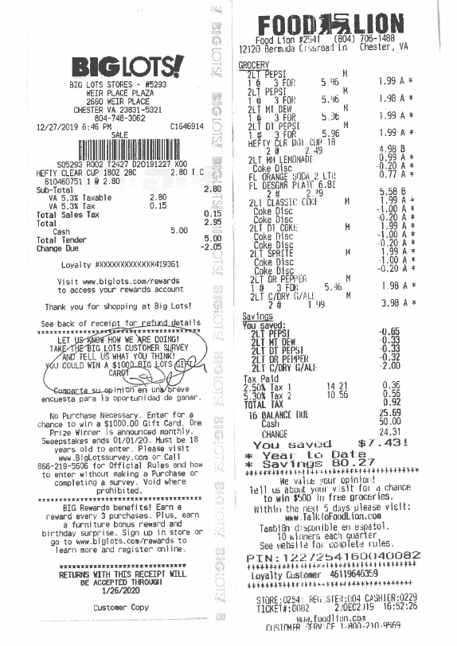
Memorabilia
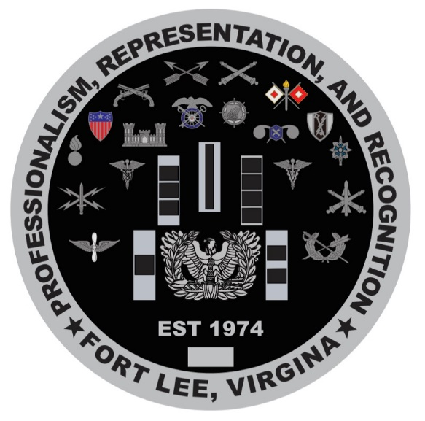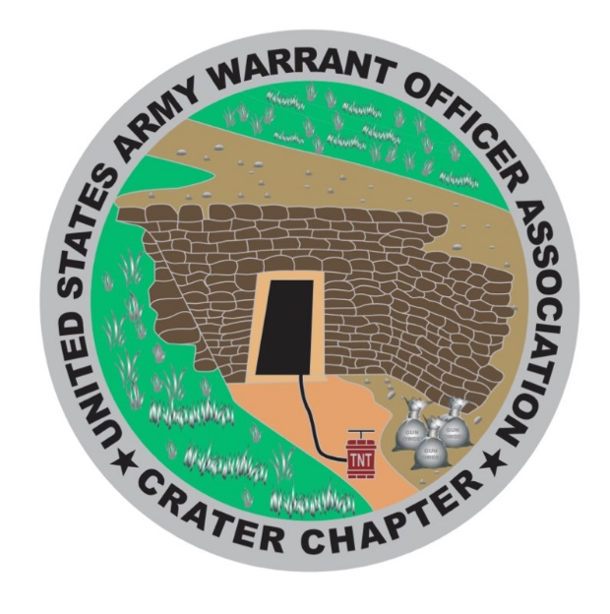

Wreaths Across America volunteers will show up and distribute wreaths Saturday December 14th at City Point National Cemetery (Avis St, Hopewell, VA 23860) starting at 11am. Also Chapter members will capture photos. We will not be selling wreaths/ conducting fund raisers for it this year due to our timeline.
Recommend we discuss in July 2020 meeting and nominate/ assign a committee lead to begin research and planning for 2020. POC: CW4 Dan Howison

JR ROTC update. CW4 Dan Howison will dig back to find the requirements decided previously and will solicit to the schools to see who will participate this year. (This is just for the public high schools, not including the school Nicky is partnering with.) (As Dan steps down from office he is willing to take on [officially] this effort [local public high schools] if the new officers wish. We can discuss in quorum at an appropriate time if needed.)

WO Ball 2020 Update:

On 2 Dec 2019, the Ball Committee Co-Leads, CW4 Pattin (Crater Chapter VP) and CW5 Elliott, visited the Richmond Marriott to coordinate the Joint Services Stateside Warrant Officers Ball for 25 April 2020. We met with Ms. Meredith Hall (Senior Catering Sales Manager) and provided our requirements.
We are currently planning between 175 - 200 attendees with reservation for 25 sleep rooms and an additional room for childcare services. Ms. Hall will email a price quote and let us know if 25 April is available – alternate date 18 April. CW4 Pattin is also working another quote from another hotel. Additional updates will be provided after quotes are received.

POC: CW5 TRAVIS T. ELLIOTT,

USAWOA CRATER CHAPTER
Treasurer’s Reports
December 2019
Placeholder

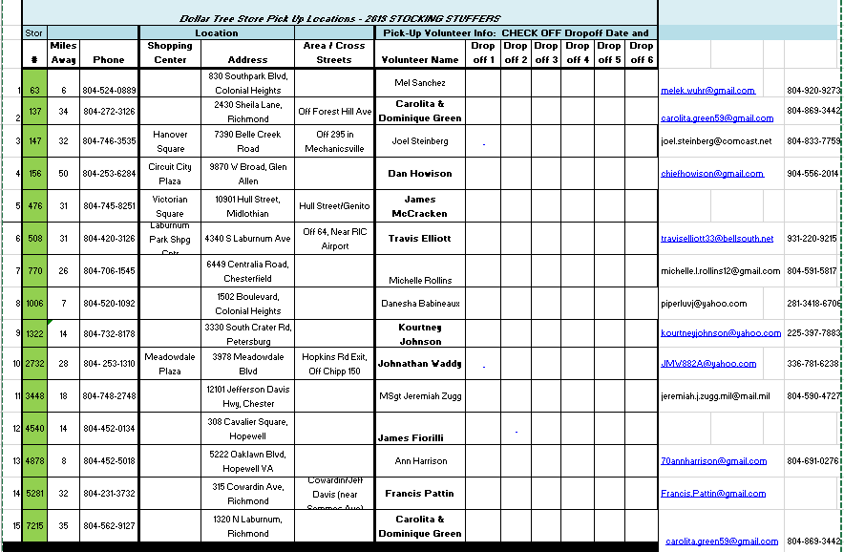

Picture from our donation to ACS that took place right before Thanksgiving!!
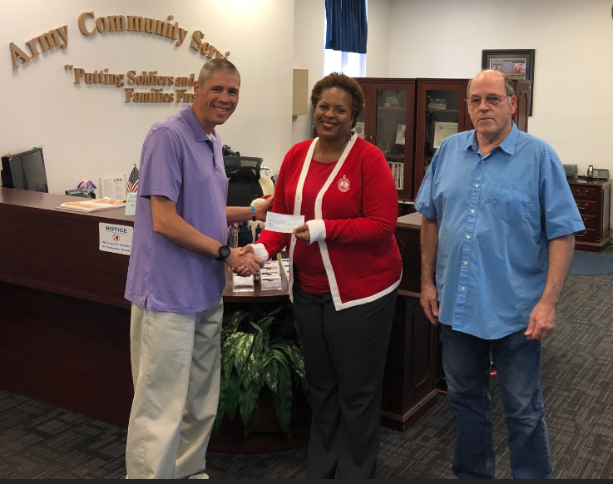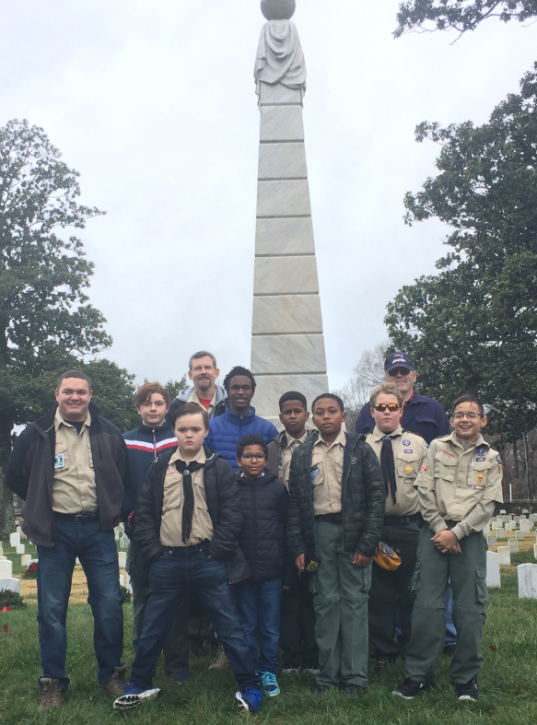
Boy Scout Troop 916 posed after Wreath Laying Presentation
Saturday 14 December at 11am the Crater Chapter participated in the Wreath's Across America ceremony/event. There were a number of volunteers that took part.

From the chapter representing the Warrant Officer Chapter:
CW4 Dan Howison
CW4R Charlie Mills
CW5R Karen Ortiz
CW4 Francis Pattin

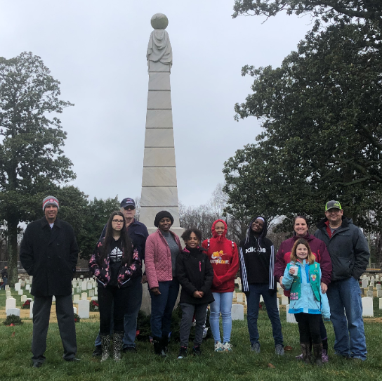
Maya Carmack (16)
Jenny Shutt
Alexis Shutt (12)
Jordan Grimes (12)
Lashondre Gross
Aysia Gross (12)
Girl Scout Troop 28
Kathryn Howison
Piper Howison (12)
Amelia Howison (19)
Jason Rogers
Nicole Rogers (12)
Cody Rogers (10)
The Crater Chapter also had some Girl Scouts, parents, Boy Scouts, and spouses that were present
laying wreath's in chapter support.

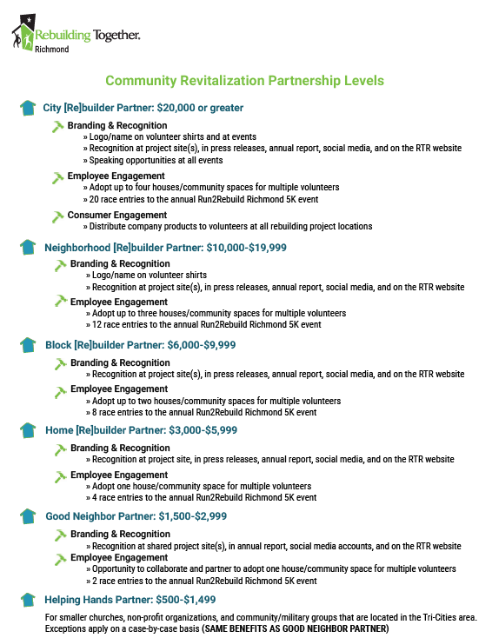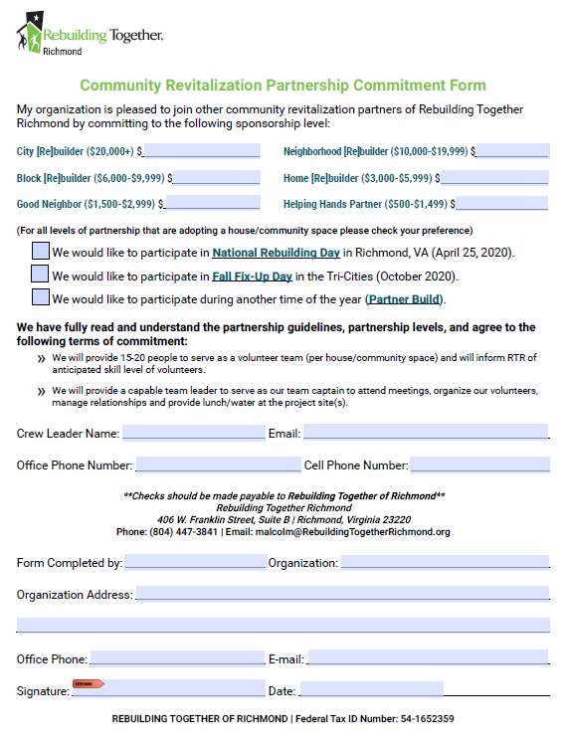
Agenda December 4th, 2019 meeting
1. Count of members to ensure a forum/forum established ( ) ID Proxies ( )
2. Call meeting to order at _________________
3. Pledge
** Swear in new Crater Chapter Officers
4. Welcome guest and new members
5. Minutes passed out and read, any discussion, motion to accept subject to edit
Motion made by ________________________________
Seconded By ___________________________________
6. Treasures Report read and any discussion, motion to accept subject to audit
Motion made by_________________________________
Seconded By ____________________________________
7. Committee Reports
a. Vice President Report CW4 Francis Pattin – CW5 James Williams- WO1 Tyrone Lander
b. Memorabilia – CW3 Karen Algernon-Wallace.
d. Volunteer Hours - CW5R Vickie Vachon.
e. Holiday Helper - CW5R Vickie Vachon.
f. Boy Scouts - CW4R Charlie Mills
g. Solicitation – CW5 Nicole Woodyard
h. JROTC – CW5 Nicole Woodyard.
i. WO Ball – CW5 Travis Elliott
j. Rebuilding TriCities – CW5 Thomas Waltman
k. Public Relations – CW5 Travis Elliott

8. Old Business
- Scholarship Questions – Action
- Scholarship write up and Traveler submission – pending Scholarship Questions.
- Warrant Officer Ball –action
- Rebuilding TriCities–action
- What’s in it for me? –action
- Crater Chapter Private Organization paperwork –action
- Bylaws. Begin January and to be complete NLT March. –action
- Crater 2020 raffle–action -need committee lead and vote

9. New Business –

10. Alibi’s
11. Next Meeting - 5 February 2020- Suite E, Bldg. 10000, near Carver Avenue & Sisisky Blvd (the Hut) at 1730
12. Adjourn meeting at (time) _________________________
Motion made by__________________________________
Seconded by _____________________________________

CRATER CHAPTER NOTES:
______________________________________________________________________________________________________________________________________________________________________________________________________________________________________________________________________________________________________________________________________________________________________________________________________________________________________________________________________________________________________________________________________________________________________________________________________________________________________________________________________________________________________________________________________________________________________________________________________________________________________________________________________________________________________________________________________________________________________________________________________________________________________________________________________________________________________________________________________________________________________________________________________________________________________________________________________________________________________________________________________________________________________________________________________________________________________________________________________________________________________________________________________________________________________________________________________________________________________________________

